Chapter 3, Solution 80

* Schematics Netlist *

H_H1 $N_0002 $N_0003 VH_H1 6
VH_H1 0 $N_0001 0V
I_I1 $N_0004 $N_0005 DC 8A
V_V1 $N_0002 0 20V
R_R4 0 $N_0003 4
R_R1 $N_0005 $N_0003 10
R_R2 $N_0003 $N_0002 12
R_R5 0 $N_0004 1
R_R3 $N_0004 $N_0001 2

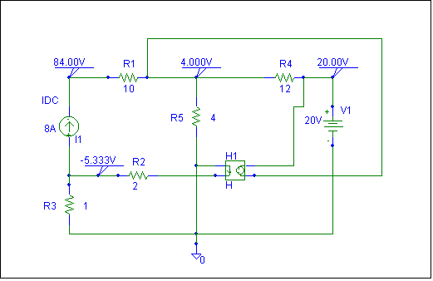

Clearly, v₁ = 84 volts, v₂ = 4 volts, v₃ = 20 volts, and v₄ = -5.333 volts

